Medium scale projects as a means for educating students on electric vehicle technology

[1]

M. Ciudin1, E. V. Enache1, M. Michailidou2, A. Samaras2 and X. Fejzo2

1 University of Craiova, 2 International Hellenic University

*Abstract*—This paper describes the collective work of a student group during two medium scaled projects in the frame of the Erasmus Plus KA2 programme “Beyond the border of electric vehicles: an advanced interactive course” with the acronym EDRIVETOUR. The projects have been elaborated during its two mobility periods, the first at the premises of the International Hellenic University (IHU) in Thessaloniki, Greece and the second at the University of Technology and Humanities in Radom (UTHR), Poland. The EDRIVETOUR program focused on educating undergraduate engineering students from different fields of study such as mechanical or electrical engineering, in the matter of electromobility and modern technologies. During the mobility periods various procedures such as the development of augmented reality applications, collection of technical specifications and datasheets of electric vehicles, 3D modelling and the troubleshooting of a battery assisted Tad-pole tricycle and a Hybrid Toyota Yaris have been overseen.

*Index Terms*—Electric Vehicles, Battery Electric Vehicles, Education, Training , Augmented Reality.

# Introduction

T

he Edrivetour Erasmus program’s main focus was the education of pregraduate students in the matter of electric vehicles and help them develop the necessary skills for to work in the electrical automotive industry. In the duration of the program the students were divided into five groups with the writers of this paper forming Group D. Throughout the mobility periods of this program the different groups were asked to develop an augmented reality app, 3D models of electric vehicles, simulation and sensing automotive applications with microcontrollers as well as maintain and ready their assigned vehicle for a racing contest. It should be noted that all the activities mentioned above were requirements needed to be met by the university students attending the Erasmus program for its completion and to eligible for receiving the according certification.

# Tad-Pole Trike Maintenance and AR Modelling

The first task to be elaborated by all student groups was the maintenance of a small-scale electric vehicle. In the case of Group D that was a delta type electric tricycle.

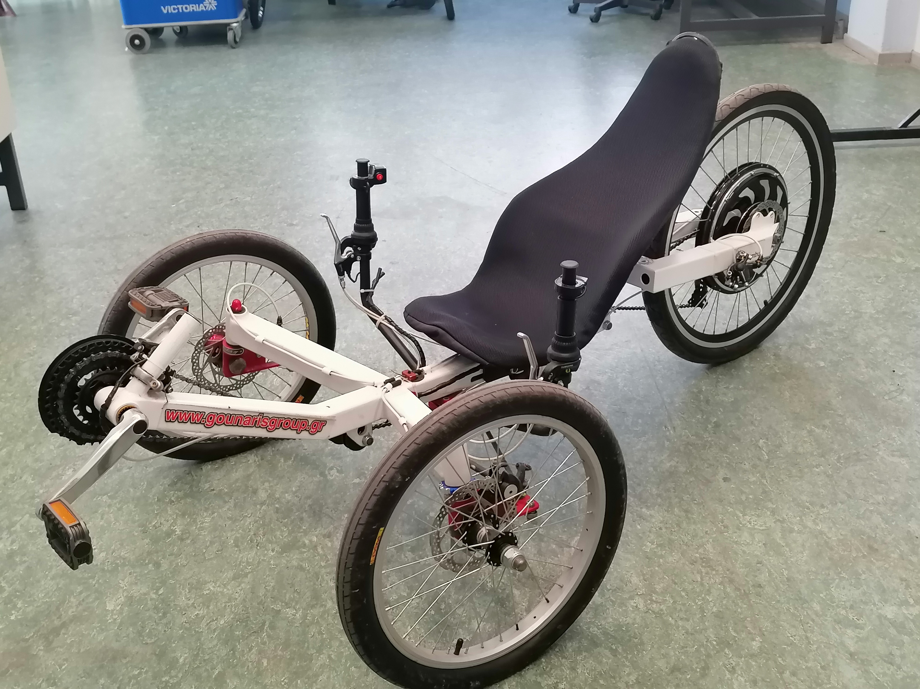

Fig. 1. The Tad-pole trike as is currently stationed in EVAE laboratory at International Hellenic University at Sindos Campus.

## Maintenance

Before any other procedure took place, it was of great importance to ensure that the vehicle provided by the hosting university (IHU) functioned properly with all the necessary mechanical and electrical parts working at their best condition. For that reason, simple maintenance has been performed under the supervision of the technician in charge. For the Tad-Pole trike a few modifications were made on the mechanical parts of the vehicle such as inspection of the proper function of the cassette, cleaning, and lubing of the chain of the vehicle and inspection of the brakes and their proper operation. On the electrical components of the vehicle the hub motors were checked through the freeware provided by their manufacturer (Miromax ltd.) [1] but unfortunately, several problems with the electronic components of the controller of the motor prevented the appropriate performance of the electrical assisted pedaling.

## Modelling and AR Application

As the use of freeware and open-source software was promoted throughout the entire Erasmus program [2], Tinkercad software [3] was chosen as the appropriate design environment for the 3D modelling of the Tad-pole trike. The specific software was selected since an STL type file was essential in its use in the augmented reality application provided as the means to develop the AR code required for the project to be appropriately completed.

After gathering all the appropriate dimensions of the vehicle [4], the 3D design was elaborated and completed in Tinkercad. Completion of the 3D model in Tinkercad software has led to the better understanding of the mechanical and electrical parts of the vehicle's drivetrain, an extremely significant issue and aim of the project. The development of the AR code in the OpenSpace3D software [5] has followed.

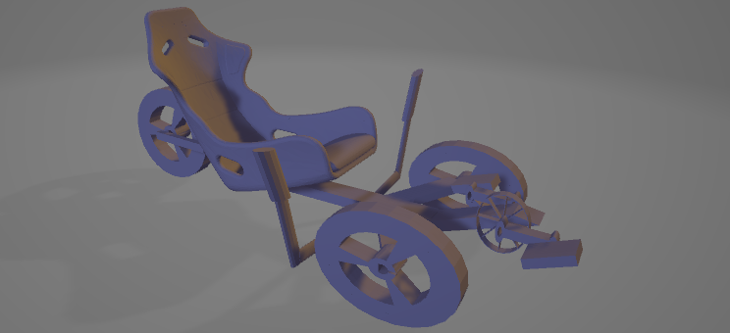

Fig. 2. The STL file of the Tad-Pole trike designed in Tinkercad software online in order to be used by the OpenSpace3D saftware.

The OpenSpace3D application has been developed for displaying the designed model in three dimensions alongside all the technical data and specifications relevant to any Tad-pole trike's information like powertrain characteristics, mechanical and electrical parts’ specifications as well as maintenance details that had been previously collected by the student group. Following the initial version of the model, extra capabilities were added to the augmented reality application, such as the simulation of the throttle circuit of the vehicle using an Arduino Uno microcontroller as a potentiometer that simulated the throttle output and displayed its reading to OpenSpace3D's user interface [6]. At the same time, another circuit with an Adafruit LCD screen Arduino shield was used to appear the throttle data to the driver in real time allowing for better driving and steering of the vehicle (Fig. 2).

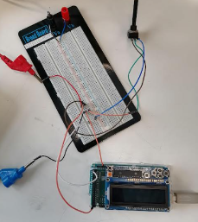

Fig. 3. Throttle circuit simulation with an Arduino Uno rev.3, an Adafruit LCD screen and a potentiometer capable of interfacing with OpenSpace3D.



Fig. 4. Throttle value that shows in real time the resistance of the potentiometer as depicted in the user interface of our OpenSpace3D application.

# TOYOTA Yaris Hybrid

Similarly, to the Tad-Pole trike case of the previous section, the student group had to troubleshoot a Toyota Yaris Hybrid. And in more details a Toyota Yaris Hybrid 1.5 HSD, P13, VNK, 55 kW model line of 2014-2020 with the 1NZFXE engine [7]. Given the cost and complexity of the hybrid vehicle, a supervising professor was present in a controlled laboratory environment. In a dedicated lab of the UTHR, the typical coding of automotive On Board Diagnostics (OBD) codes was used in order to troubleshoot the given vehicle. It is important that real time driving conditions were simulated by means of chassis dynamometer and that all graphs depicting the state of charge status of the battery and the rotational speed of the electric motor were collected and recorded through the Bosch ESItronic 2.0 software and the Bosch KTS 570 diagnostic tool.

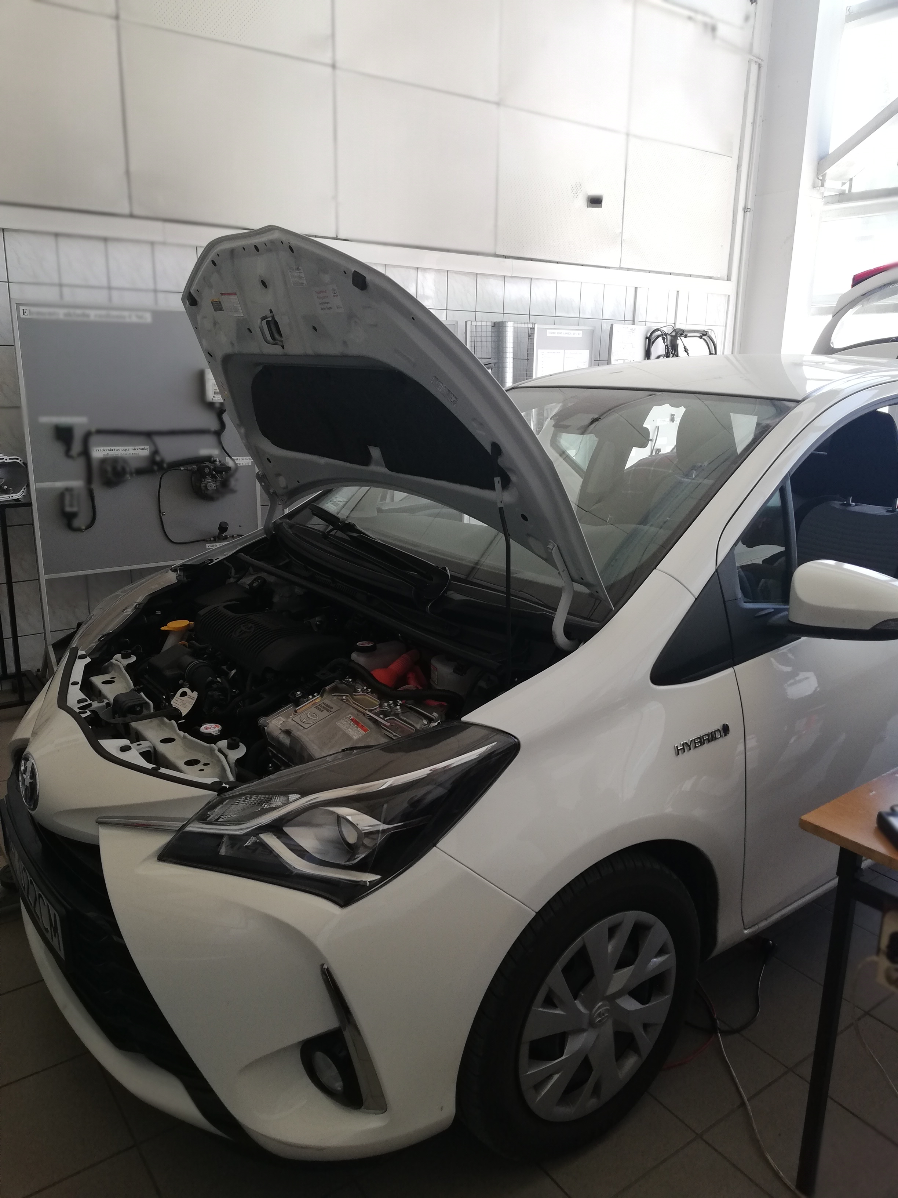

Fig. 5. The Toyota Yaris Hybrid vehicle that was available to students of the EDRIVETOUR program at the University of Radom UTHR .

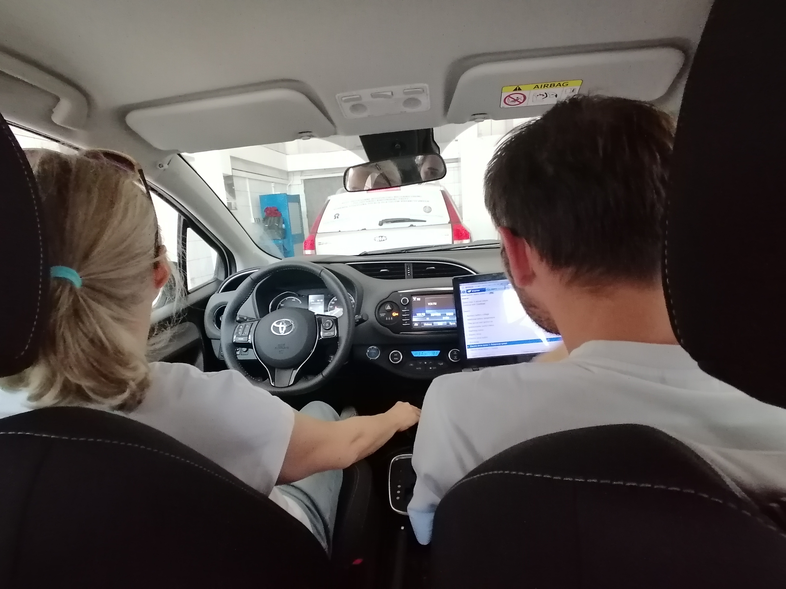

Fig. 5. Our data collection process in which the supervisor professor drives the hybrid vehicle while our computer is connected to the vehicle with the Bosch KTS 570 diagnostic tool.

## The hybrid propulsion system

Since the vehicle is hybrid, an internal combustion engine (ICE) also exists on board. Fig. 3 depicts the 3D model of the 1NZFXE propulsion system of the vehicle under test. It consists of the ICE together with the electric motors of the hybrid vehicle. The ICE is a first-generation gasoline engine with an economy narrow angle overhead camshaft, a hybrid Atkinson combustion cycle along with multi point electronic fuel injection capable of reaching a power output of 56 kW at 5,000 rpm and a torque output of 110 Nm at 4000 rpm with no power adder. The engine provides power to the vehicle as well as the generator that charges the battery pack of the hybrid vehicle and its usage is triggered by the vehicle computer.

It should be noted that this type of engine is actually used in the Toyota Prius, Prius C, Yaris, Corolla and Sienta models. It’s production started at 1997 with displacement at 1.5 L and standard compression pressure being at 9.0 kg/m2 with the total weight of the engine reaching 87kg and consuming 0.5 liters of 5W-30 oil per 1000km .

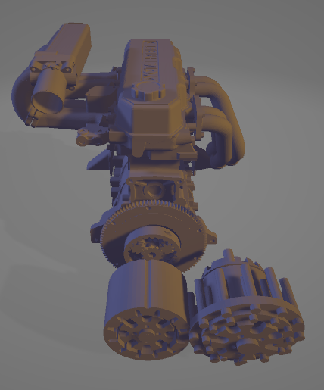

Fig. 6. The 1NZFXE combined engine 3D design showing the characteristic planetary gear of the power split device of the vehicle and in the front the two alternating current synchronous motors.

Another important feature of the vehicle’s propulsion system is the two three-phase 45 kW AC motors that are used interchangeably mostly as a generator and motor, with the motor providing power to the front wheels while the generator powers the transaxle and battery pack of the hybrid. In that way kinetic energy throughout deceleration of the vehicle’s front wheels is recovered and through regenerative braking charges the battery pack. Normally, the battery pack also charges through the planetary gear that is powered by the ICE of the vehicle, so charging is also achieved by accelerating the hybrid making the Toyota Yaris a quite energy efficient driving option.

The system main relay which is responsible for connecting and disconnecting the HV battery is another main important feature of the vehicle worth mentioning. With the activation of the positive side of the contact relay by the ECU the relay is powered on. Then the negative side of the contactless relay which is located inside the inverter closes the loop through a resistor resulting in the negative side of the contact relay also powering on. Thus, while this operation is taking place there is no chance of rush current producing dangerous sparks that could in turn lead to a fire hazard for the vehicle. However, that isn't the only use case of the system main relay since in the chance of a side or front collision the ECU after registering the impact signal from the circuit breaker sensor or the airbag assembly sensor triggers the system main relay to turn off thus preventing any further damage to the vehicle.

## The Battery charging system

As was the case with the Tad-Pole Trike, the battery pack was also simulated in Tinkercad software as a 3D model and exported as an STL file for its usage in the OpenSpace3D software. The battery pack of the hybrid vehicle consists of a 12V lead-acid battery, which is located under the right rear side seat and powers all the low voltage devices of the car and is grounded to the metal chassis of the vehicle following most car design principles. The other battery pack with total voltage of 144V is comprised of 20 Nickel Metal Hydride (NiMH) batteries connected in series with each one containing 7.2V and in total weighs 31 kg. It should be noted that this battery pack is charged only from one three-phase AC electric generator while it provides power back to the electric motor and generator, the inverter or converter as well as the A/C compressor of the hybrid.

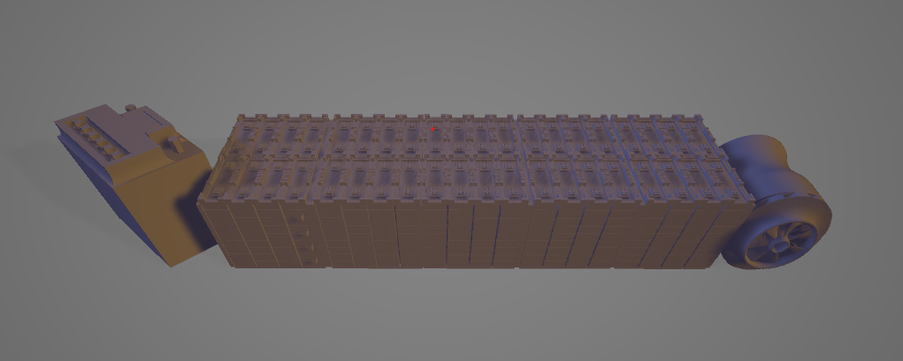

Fig. 7. 3D model (left to right) of the backup lead-acid 12v battery and the lithium-ion battery consisting of 48 cells reaching the nominal voltage of 177.6 V and capacity of 4.3 amp/h.

## Measurements

The measurements performed on the hybrid Toyota Yaris are depicted in Figs. 8 and 9.

In Fig. 8 during the braking of the vehicle, if all the kinetic energy is absorbed by regenerative braking or not. Through our readings we were able to see a maximum regenerative brake torque of -191 Nm and figure out that after reaching that regenerative brake torque the rest of the braking energy is absorbed by the brake pads of the vehicle. Moreover, a general observation was that whenever the break was pressed severely the battery recharged about 1 to 2 percent of the overall state of charge.

In Fig 9 after the previous experiment done with the help from the supervisor professor, we continued the collection of data utilizing only the electrical motor and battery to provide propulsion to the vehicle. This was accomplished by enabling the EV mode on the vehicle where after driving it around the university campus we were able to record as maximum motor speed 2851 rpm as shown in the graph below.

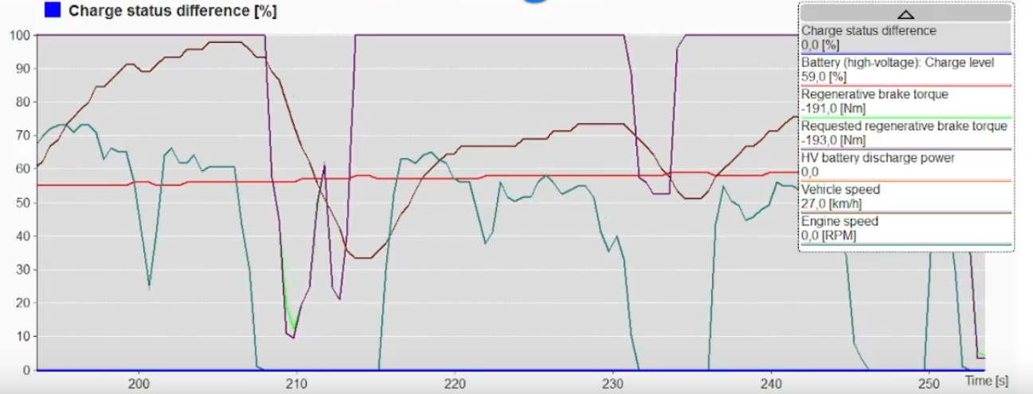

Fig. 8. Graph showing the Charge Status Difference of the vehicle during deceleration and the regenerative brake torque of the vehicle (green) reaching the -191 Nm.

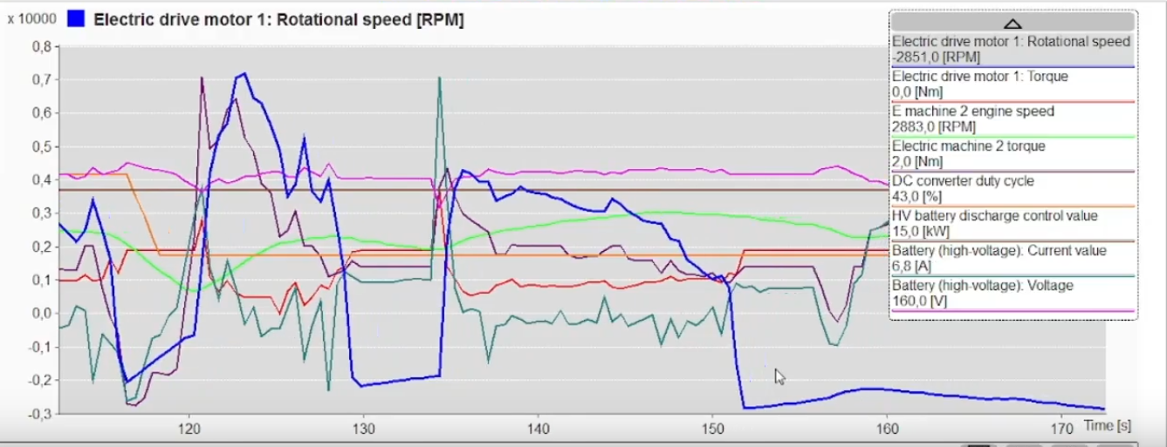

Fig. 9. Figure from the Esitronic program showing the vehicle utilizing its electric drivetrain only and reaching -2851 rpm from its electric drive motor.

## Data collection

All files and documents with measurements data created during all laboratory experiments of the project are available online in a Github repository [8].

# Acknowledgements

All content presented in this paper has been created by the authors and funded by the European Union under the ERASMUS PLUS KA2 with GA 612522-EPP-1-2019-1-EL-EPPKA2-KA project entitled “Beyond the border of electric vehicles: an advanced interactive course” with acronym EDRIVETOUR.

References

1. Miromax Empowering Solutions, Available: https://www.miromax.lt/en/
2. Erasmus Plus KA2 GA 612522-EPP-1-2019-1-EL-EPPKA2-KA “E-DRIVETOUR: Beyond the border of electric vehicles: an advanced interactive course” Available: <https://www.EDRIVETOUR.eu/>
3. Autodesk Tinkercad, Available: <https://www.tinkercad.com/>
4. V. Karidas and G. Kontozisis, Design and Construction of tricycle with pedal assist. Diploma Thesis, Alexander TEI of Thessaloniki, Sept. 2013.
5. OpenSpace3D – Open Source Platform for 3D Environments. Available: https://www.openspace3d.com/ Accessed: 8/5/2022
6. T. Anagnostaki, “EDRIVETOYR TS1.12 Intermediate Project – OpenSpace3D Computer Lab notes” – Accessed: 21/09/2022
7. Toyota UK Media Site – Toyota Yaris Hybrid Technical Specifications. Available: https://media.toyota.co.uk/wpcontent/uploads/sites/5/pdf/210713M-Yaris-Tech-Spec.pdf
8. Github Repository of EDRIVETOUR Intermediate Project. Available: https://github.com/MariaMich/EDRIVETOUR-Intermediate-Project

1.